X/Z Reports

Information

Soluone

CASH COUNT

Cash count is an audit process for request the current money for each payment methods.

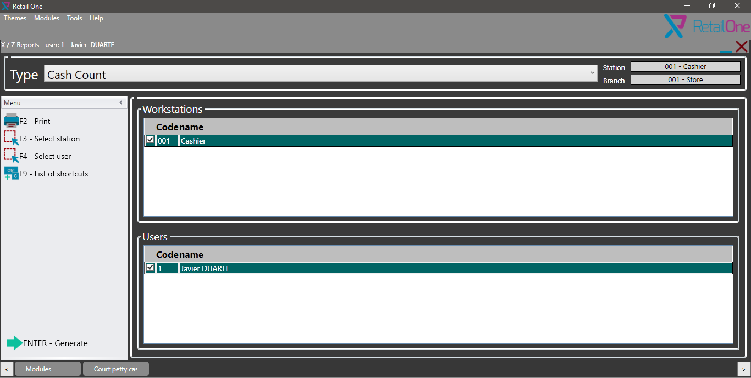

X REPORT

This is for mark the work shift end, in the store we can have many work shift, for inform to system this change we execute the x report and with this all transaction are related to this x report folio.

Z REPORT

Z report is for close the day, this process list all x reports generated in the day for generate the operation total for this day.

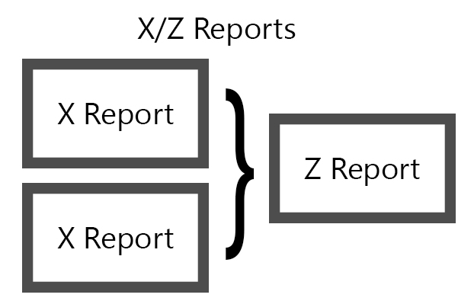

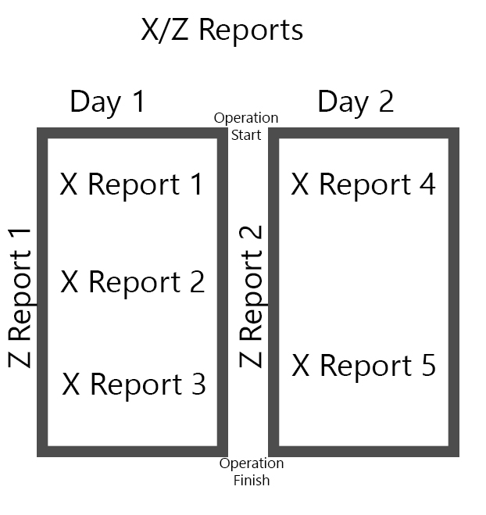

Schema for X and Z report.